Scaling and Safety: The Operating Vehicle World: Specifications and Functions

Introduction
For operating vehicles, the RTS representation in Chapter 3 Context and Structure: Road Transportation System states that these are categorised into groups and phalanxes.

The closest analogy to the phalanx is a murmuration. The murmuration is the view of a flight of a large number of birds as seen by a human on the ground. The human view is concerned with the shape of the murmuration, its direction and speed. When looking at a murmuration, the positioning of the individual birds is not a consideration. In this respect a murmuration is similar to the concept of the phalanx. The phalanx is a multi-agent collection of vehicles as viewed from the Traffic Management System perspective.

The overall shape of the murmuration forms from the swarm intelligence and behaviour of the individual birds responding to distance, heading, and speed requirements of their proximate seven neighbours (Reynolds, 1987). This behaviour can fulfil a safety requirement. Within a group, vehicles are concerned with swarm behaviour of structure, speed, and avoidance, not to be confused with the phalanx is the view of those vehicles, taken as a unit, from an external perspective and which serves to address free flowing traffic goal of the RTS. The structure of the group is constrained by both the physical infrastructure, and the positioning required due to navigation and a need to exit from the group (Wood & Beale, 2019). It is known that within a murmuration individual birds change their position

From the perspective of the individual vehicle and the Traffic Management System, the rules for the murmuration and the group are simple and very similar. The group abides by swarm rules, while the phalanx is that same group of vehicles seen from the perspective of the Traffic Management System. To the Traffic Management System, the murmuration is a collection of phalanxes behaving equivalently to a swarm constrained by the infrastructure and which are manipulated to achieve free-flowing traffic. The Traffic Management System is outside the scope of this thesis but where there are interactions between autonomous vehicles and the Traffic Management System, axioms are defined from the perspective of the autonomous vehicle.

The operational vehicle world
The operational vehicle world is a dynamic artefact associated with the Traffic Management System which has the role of ensuring free flowing traffic among operational vehicles. The Operational_Vehicle_World is distinct from the Vehicle_World which is similar in concept to the DVLA. The Vehicle_World is represented as static knowledge. The Vehicle_World holds the totality of authorised autonomous vehicles which could at some point become operational. The Operational_Vehicle_World is a dynamic knowledge base which is concerned only with those authorised autonomous vehicles currently in operation.

It should be recognised that the actual vehicles on the road at any one time will be a subset of the totality of vehicles in the Vehicle_World as defined in Chapter 6 Scaling and Safety: Autonomous Vehicles World: Specifications and Functions. To state that the number of vehicles on the road, even at rush hour, is fewer than the number of vehicles registered with DVLA is not contentious. Each of the autonomous vehicles on the road has a unique identifier gained during the initialisation process and belongs to uniquely identified group and phalanx. Individual vehicles may be monitored by different authorised monitoring bodies; this is a legal requirement and does not otherwise impact the representation of the RTS. To satisfy the goal of purposeful traffic, an operational autonomous vehicle must be associated with an origin and destination in terms of a journey.

It is noted that the implication of defining an Operating_Vehicle_World is that there must be a process/procedure for adding authorised vehicles to that set, either from a static set as in the case of domestic vehicles, or a dynamic set as in the case of foreign vehicles. The addition must occur to the Vehicle_World which is the static representation of all domestically authorised vehicles. Removal from Operating_Vehicle_World must also be accommodated and occurs when the vehicle stops its operation, terminating ignition.

Why does the RTS need a group and a phalanx?
For operating vehicles, the RTS specification states that these are categorised into groups and phalanxes. Within a group, vehicles are concerned with swarm behaviour of structure, speed, and avoidance, while the phalanx is the view of those vehicles, taken as a unit, from an external perspective.

The closest analogy to the phalanx is a murmuration. The murmuration is the view of a number of birds as seen by a human on the ground. The human is concerned with the shape of the murmuration, its direction. It is similar to the perception of the phalanx from the traffic management perspective.

When looking at a murmuration, the positioning of the individual birds is not a consideration. The overall shape of the murmuration forms from the swarm intelligence and behaviour of the individual birds responding to distance, heading, and speed requirements of their neighbours. Likewise with the group of vehicles. The rules are simple and very similar. The partial purpose of the vehicle which contributes to the goal of the RTS is one of safety, i.e., avoidance which relates to the distance between vehicles and other obstacles, and to travel in free-flowing traffic, which relates to the speed at which others in the group are travelling.

The partial purpose of the vehicle which contributes to the goal of the RTS is one of safety, i.e., avoidance which relates to the distance between vehicles and other obstacles, and their relative positioning and structure which relates to a requirement to be on the edge of a group when nearing an exit as determined by the navigation system. Under the auspices of the Traffic Management System, which is concerned with effective use of the infrastructure, and achievement of free-flowing traffic, that same group is also considered from the perspective of the Traffic Management System. In order not to confuse which contribution to the purpose and goals of the RTS is being addressed, the use of the word group is reserved for safety considerations achieved through swarm behaviour, whilst the use of the word phalanx is reserved for that same group of vehicles as viewed by the Traffic Management System.
The simple answer to the question in the title of this section is that it makes the solution and implementation of that solution less complex and easier to scale, under the divide and conquer maxim, even though it might be thought, in the first instance, to add to complexity or increase redundancy. It is the acknowledgement that safety is the result of a swarm function contributing to the individual autonomous vehicle in fulfilling its purpose, while free traffic flow is a Traffic Management System consideration. Having a group and swarm structure splits both the computational complexity and network traffic, enabling effective and efficient communication. The simple concept of the group works well until the reality of the rush hour on the M25 as indicated in Figure 19 is considered:

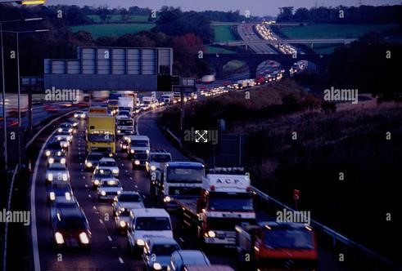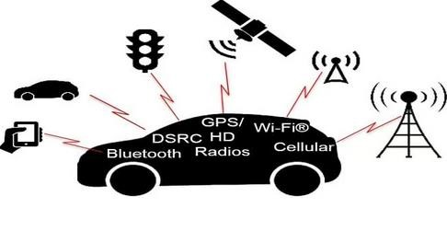
Figure 19: London Ring Road M25 with morning rush hour traffic near Gerrards Cross Buckinghamshire NW of London, England (Servian, n.d.) and potential vehicle connectivity (Bridgelall, 2018)

For each individual vehicle to be in communication with the infrastructure and traffic management system is not scalable without the degradation of network performance (Al-Obaidi, 2010).
The collection of vehicles into a phalanx responsible for external interaction with the infrastructure and authorised monitoring body reduces the complexity of implementation and required volume of communication. The situation such as the M25, rapidly degenerates into extreme complexity. Neighbouring swarms and overlay networks have been investigated (National Cyber Security Centre, 2020) but consideration of intersecting murmurations reveals that positioning of the individual becomes an issue. For real time, high-speed, safe, operation, it may be necessary to limit the number of constituent vehicles in a group, thus the size of the phalanx, for purposes of efficiency, bandwidth, and capability. The indicative structure for a multi-swarm with a phalanx overlay is given in Figure 20:
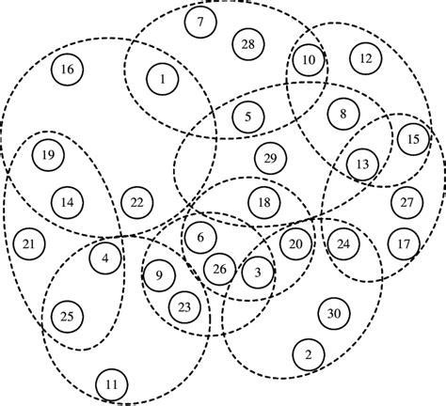
Figure 20: Multi swarm topology (Abraham, et al., 2011).

It is not that the concepts of group and phalanx will not work, but that within a designated group, to some extent the structure is based on the destination and the need for a vehicle to be at the edge of its group prior to departure. The infrastructure is linear, so the degree of overlay shown here does not lend itself to representation of groups of vehicles i.e., controlled streams of traffic, or ease of traffic management. A data fusion and filtering mechanism (Castanedo, 2013), the phalanx, is considered necessary. (For clarification purposes, the Castanedo article uses the terms DAI (data in) and DAO (data out), which terms are not used in this thesis and are not to be confused with the DAO (Distributed Autonomous Organisation) discussed.

As a goal of the RTS is use of the infrastructure in pursuit of efficient and effective purposeful traffic, the concept of a group of vehicles belonging to a particular phalanx enables that phalanx to be diverted to a less congested part of the infrastructure thus increasing the efficiency of travel. Although the above M25 illustration relates to the cyberphysical system, it demonstrates exactly what the Traffic Management System is seeking to avoid.

Maximising the size of a phalanx before the formation of a second phalanx would enable the Traffic Management System to redirect or divert the first phalanx to a different part of the infrastructure in the event of anticipated congestion. The phalanx via the infrastructure would communicate with the Traffic Management System in response to a reduction in speed caused by congestion or some other occurrence, known or unknown to the phalanx.

There is a processing overhead attributable to the dynamic nature of a group and phalanx which would require optimisation. Chapter 9 Digital Security: Fortified Cyber Defence, Resilient Cyber Defence and Trusted Autonomous Systems addresses the tokenisation of identity to enable asymmetric cyber security advantage to the group and phalanx. Outwith any implementation of evidentially useful blockchain technology, the aspect of a DAO remains useful in the definition of rules of operation for the group and phalanx.

Distributed Autonomous Organisations (DAO)
The similarity between the group/swarm and a distributed autonomous organisation is identified and is the subject of implementation considerations, hence outwith the scope of this thesis. However, as a novel solution, it is discussed further here.

Groups and phalanxes are artificially constructed elements of the RTS. The traffic management system thus achieves management of the operating vehicles via infrastructure and the phalanx relaying bidirectional data or instructions from the traffic management system. The phalanx references, as a component in its type definition, a group. The group and phalanx most closely align with decentralisation and hierarchical control. This arrangement reinforces the defined structure of the RTS in respect of operating vehicles and demonstrates the distinction between the internal cooperative functioning of the group or swarm, associated with safety, and the phalanx which is seen as a single entity subject to the control of a different part of the RTS, the traffic management system via the infrastructure, associated with the goal of free flowing traffic. Other than within the group, the autonomous vehicle has little independence of action and is predominately under the direction of other elements of the RTS.

A Distributed Autonomous Organisation (DAO) is a self-determining entity which members have a common goal. The members, like a group or swarm, act in accordance with a defined set of rules or smart contract. The rules are encoded and there is no opportunity for a member to act outside those rules.

In terms of implementation, the group and phalanx are dynamic abstract constructs that may be most appropriately modelled as hierarchical DAOs which in turn will enhance security. The group is self-organised according to a swarm algorithm while the phalanx can have a data disseminating role associated with onward transmission of telematics, a data fusion role with the infrastructure. It can act as a non-essential relay in the transmission of the monitoring data from the phalanx members, the individual vehicles comprising the group, and the authorised monitoring body. This purpose is based on efficiency and the transmitting power of the infrastructure, but this may not be the implementation chosen.

Any further implementation detailed discussion is outside the scope of this these, but its consideration here is to demonstrate that rules can be hierarchically defined throughout the RTS system and its elements and the need for them becomes apparent in further analysis.

Ruane & McAfee (2022) define the characteristics of a DAO thus: …. a functioning DAO requires …. a set of smart contracts that form the DAO’s core operating system …. self-executing computer programs used to enact decisions …. without human involvement. These contracts…. always perform as written…. Getting these codified rules correct from the outset is important. Even small errors or omissions can cause …. operational failures later on, such as security vulnerabilities …. This definition enables the identification of elements of the RTS as decentralised autonomous organisations (DAO) while at the same time, from a different perspective being hierarchically connected via differing, more appropriate to their purpose, network structures.
Immediately springing to mind are the group with its rules governing swarm behaviour, a DAO which comes together with a common goal, safety. The phalanxes which are perceived as distinct units within the control or authority of the traffic management system responsible for relaying data and commands from the infrastructure to the individual vehicles for whom they act as relay are a different DAO, and the rules for defining any selection of a primary and/or secondary communicating element within the phalanx could be encoded in the relevant smart contract.

Use of DAOs leads to consideration of interoperability issues. The choice to use DAOs is a policy decision.

Stigmergic systems
Stigmergic systems can overcome the difficulties and costs by taking advantage of agent technology and the self-organizing property of stigmergy, indirect coordination between agents and actions which have consequences either on the acting agent or others within the group (Heylighen, 2016), and evolutionary dynamics (Novak, 2006), This applicability of the aforementioned are assumed within the group.

Here it is proposed that the application of stigmergy is appropriate and proven (Spieldenner & Chelli, 2022) for the swarm behaviour and swarm intelligence of the group which is solely concerned with the direction, distance and speed of other members of the group in its designated behaviour for the operational functions of stop, go, avoid as presented in Chapter 6 Scaling and Safety: Autonomous Vehicles World: Specifications and Functions. The rules of any swarm behaviour extant from research can be applied to achieve the integrity of the internal structure of the externally perceived phalanx, thereby achieving the goal of safety.

Tokenisation and unique identity
Tokenisation will be applied to the identification of members of the group and to the phalanx itself. Creation of the group and phalanx identifiers coincide with the ignition of an autonomous vehicle. As shown in the process diagram in Figure 21, the source of that creation resides in differing elements of the RTS and includes a temporal element which usage contrives to provide a unique identifier. The concept of this unique and dynamic generated/created identifier is to limit the opportunity for hacking as the identifiers are reasonably short-lived within the operational autonomous vehicle world.

The vehicle, group, and phalanx identities are further useful in post event investigation and identification as an indicator of what event has happened to or has been caused by a particular autonomous vehicle and with which other vehicles it was travelling at the time.

A tokenisation/registration process executes when a vehicle initiates its operation i.e, ignition. Identification details about the vehicle, which have included time of initialisation generate unique identifications for each initialisation, and are passed among elements of the RTS involved in the process. For the purpose of clarification, a suggested process will be discussed. It is recognised that the actual process may differ substantially from that suggested here.

The authorising authority determines whether that autonomous vehicle and its authorised monitoring body are permitted to operate. It passes the identification data to the operating vehicle authority, part of the traffic management system. Operating identities are created for the vehicle, its group and phalanx. This registers the vehicle as operating and requests notification of initialisation of operation from the relevant authorised monitoring body to the autonomous vehicle. At the same time, the phalanx identification token and its constituent data are passed to the traffic management system, identifying the vehicle as operational within the RTS.

When confirmations from the Authorising Authority, the authorised monitoring body and the Traffic Management System are in the ownership of the autonomous vehicle, proving established communication, the autonomous vehicle enters into required communication with its authorised monitoring body. The phalanx identification is sent to the infrastructure which notifies the traffic management system of the location of the newly operational vehicle.

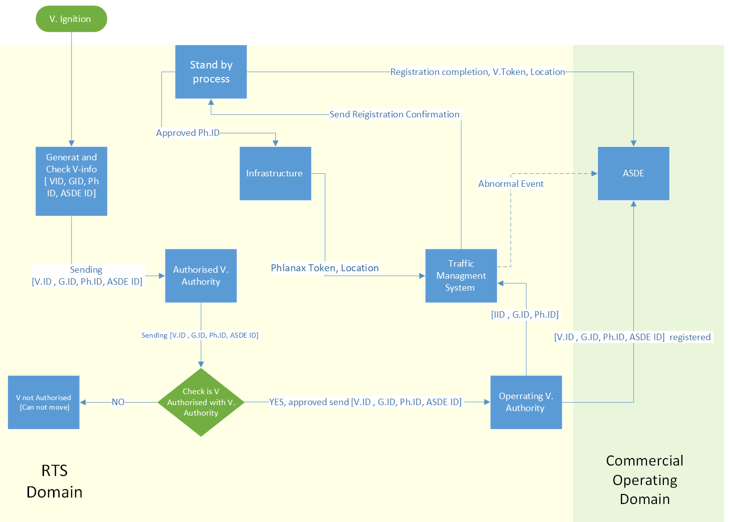
Figure 21: Operating vehicle registration process.

The group and phalanx are synthetic constructs of a collection/set of one or more autonomous vehicles as represented in the RTS and derive from the considerations of stigmergic systems. Where a number of vehicles are travelling together and constrained by the infrastructure, this is commonly called a stream of traffic, a convoy, a platoon, or in this thesis, a phalanx, but there are distinct differences in the purposes and objectives of the group and the phalanx.

Using synthetic abstract constructs in this way is not new (Nettleton, 2003). Nettleton provides a sound mathematical basis for information filtering and information fusion confirmed by Cariou, et al (2019). As indicated, when discussing stigmergic systems, the goal is to reduce the complexity of both communication and data transmission to where it is functionally needed to fulfil a particular purpose.

From the perspective of the autonomous vehicle, the ultimate purpose of the phalanx is the data fusion from its constituent vehicles for efficient transmission to the infrastructure, thence to the traffic management system, possibly to act as a relay for constituent vehicle transmissions to the associated authorised monitoring body and to receive instructions concerning traffic management which are received from the infrastructure thence transmitted to the constituent vehicles. Cyber defence is maintained through the contribution of the tokens passed and evaluated with each transmission as indicated in Chapter 9 Digital Security: Fortified Cyber Defence, Resilient Cyber Defence and Trusted Autonomous Systems.
The infrastructure/phalanx handoff as the phalanx progresses through the infrastructure is not addressed as it concerns traffic management thus is out of scope.

Operational vehicle world

Proposed method of working for group and phalanx
It has been indicated that the initially, the individual autonomous vehicle is a member of both a group and a phalanx with cardinality 1. These elements are initiated on ignition and thus the tokens are known to both the group and phalanx. At the moment the phalanx and infrastructure communicate, it is possible for the Traffic Management System to match the token to that held by an authority for operating vehicles. The vehicle identification token must be transmitted by a central authority and autonomous vehicle to the relevant authorised monitoring body which immediately commences monitoring.

The vehicle and its associated group and phalanx can merge with another group or phalanx as it encounters them subject to the possible limitation of numbers in a group and phalanx as discussed previously. As vehicles leave the group as a result of the navigation requirement, there is a need to recalculate the phalanx and group identification tokens which are based on all vehicle identification tokens within the phalanx and group to which the phalanx acts as relay within the hybrid mesh.

In a changing multiple vehicle group, the phalanx recalculates the value of its phalanx identification hash; similarly with the group. Transmission of the new hash value is transmitted to the infrastructure. The previous phalanx identification token, and its historical associated data is either discarded or stored within the traffic management system. Failure to complete this aspect of the process is not a cyber security issue, but one of resilience, dependability, and traceability, thus a development issue and a policy issue in respect of storage.

The dynamic nature of the group and phalanx limits the time window available to an external hacker. The inclusion of timing renders any tokens available for a limited period, reducing the opportunity for hacking and introducing asymmetric cyber security advantage. There is not a single path associated with creation and passing of tokens to the autonomous vehicle. Even where a time of day is known for ignition, there is the potential for limiting the hack to a single vehicle, and a limited number of actions available to the hacker. Attempting a hack becomes the equivalent of bitcoin mining and guessing the nonce.

There is no prospect of cross contamination between groups and phalanxes as the identification tokens are unique to hashing of constituent vehicle identifications and a temporal element based on time of ignition or creation of the group or phalanx, inter alia. For the phalanx which acquires its initial identification token on ignition, it would be a rare event that a stream of traffic would be constant and have continuously static membership for an extended period of time and have no stop or reignition. In this way, it is made uneconomic for the hacker who is looking for a large and quick return. The fortified defence involving isolation and segmentation together with the tokenisation addresses the rejection of denial of service attacks which are feared by first responders as they would have the potential to prevent first responder vehicles from operating.

Although Liu et al. (2022) did not have the constant issues of potential maritime traffic jams in a restricted infrastructure outside of dense shipping lanes or ports, the division of functionality for unmanned surface vehicles shown in Figure 22, is similar to that described for the group and phalanx in relation to the traffic management systems, the infrastructure, the monitoring authorised monitoring body and the authorisation authority.
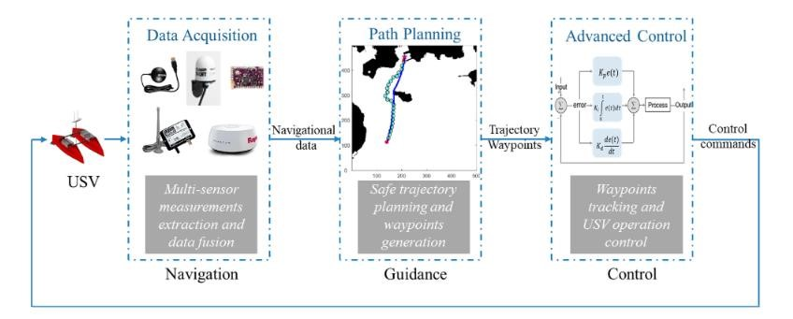
Figure 22: Autonomous Navigation System of an unmanned surface vessel (Liu, et al., 2022).

Phalanx and group construction and functions
The definitions not included within this section are taken from Chapter 3 Context and Structure: Road Transportation System.

The group
Within the RTS, the group behaves as a swarm. The members of the group are concerned with the vector, direction and speed, and avoidance of its neighbours. The work of (Reynolds, 1987) mathematically modelling boids, is directly applicable when a Lagrangian approach is taken (Price, 2024). Its use is more complex in a futuristic three dimensional world of airborne vehicles and integrated drone systems. Using the Eulerian approach for large swarms can lose the heading element of the vector (Topaz & Bertozzi, 2004), (Toner & Tu, 1995).

The goals for vehicles, as defined in the RTS, are almost identical to those for Reynolds’ boids (Reynolds, 1987), (Essam, et al., 2023), which, apart from the RTS’s purposeful traffic issue of getting from A to B, allows the imposition of research into swarms or multi-agent groups to be considered. The works of (Barciś, et al., 2019) and (Silva & Nedjah, 2016) provide a good starting point for the formalisation of the required swarm/group behaviour.

The group is the collection of autonomous vehicles that are constituent members of the phalanx. Within the group the purpose of the autonomous vehicles is paramount: in accordance with the behavioural functions is_permissable, is_possible, or is_capable, a vehicle will stop, go, or avoid an obstacle. Swarm behaviour dictates that this is a comparatively simple set of operations, quite apart from the operation of the individual autonomous vehicle, its sensors and internal systems.
Reynolds (1987) states that his work on simulated flocking identified causative behaviours.
- Collision avoidance
- Velocity matching
- Flock centring or attempting to stay close to nearby flockmates

This parallels, as previously stated, in order for a vehicle to contribute to the goals of the RTS, it must:
- Get from a predefined A to a predefined B
- Avoid all and any obstacles
- Be in free-flowing traffic throughout its journey

The group fulfils the safety requirement of the RTS through collision avoidance, velocity matching, and coherence.

Swarm intelligence is concerned with the collective behaviour of decentralised multi-agent systems which interact (Beni & Wang, 1993). It is not certain that the generalised use of autonomous vehicles will coincide with the arrival and adoption of collective intelligence, a hivemind (Bonnet, et al., 2019)…amplifying intelligence, wisdom, and intuition of the participants….through a convergence of opinions… (Dorri, et al., 2017) whereby the group may become redundant, although concerns of allowing potential emergent properties, as discussed and addressed in Chapter 2 Methodology: Mathematical Representation of Complex Systems, will remain. The phalanx being an artefact of the Traffic Management System may not be redundant.

Group and Phalanx construction invariant intention
- The constituent members of a Group and Phalanx are identical
- The autonomous vehicle can belong uniquely to a Group and Phalanx
- There is no vehicle in a Group or Phalanx which operates above the capability of the minimally capable vehicle
- The cardinality of the Group and Phalanx is greater than or equal to one
- The phalanx knows the vehicles in its Phalanx
- The vehicle knows the Phalanx
- The group knows the vehicles in the Group
- The vehicle knows the Group

Group and Phalanx construction invariant

(∀P ∊ {Operating_Vehicle_World.Phalanx},
∀G ∊ {Operating_Vehicle_World.Group},
(∀v ∊ P), (∀v ∊ G)) .

({G.v} = {P.v}) ∧ ¬(∃v.capability < D_{GP}ψ_{min}.capability)) ∧ (v ∊ P ∧ v ∊ G)
∧
(∀P ⊂ Operating_Vehicle_World .Phalanx . (P = {v} | (|P| ≥ 1))) ∧ ((∃!P | (v ∊ P) ∧ (knows(P,
C_{vP}ψ) = TRUE) ∧ knows(v, (K_{v}ψ ∪ K_{vP}ψ) = TRUE)))
∧
(∀G ⊂ Operating_Vehicle_World_Group . ((G = {v} | (|G| ≥ 1)) ∧ ((∃!G | v ∊ G) ∧ (knows(G, C_{vG}ψ)
= TRUE) ∧ (knows(v, (K_{v}ψ ∪ K_{vG}ψ)) = TRUE))

Group functions
For all group functions specified here, the invariant must obtain.

Join_Group(v, G) → ((G' = G ∪ {v}), (C_{G'}ψ' = C_{G'}ψ ∪ C_{vG}ψ), C_{G'min}ψ', v, (D_{vPG' =} D_{vPG} ∪ K_{vG}ψ))

Leave_Group((v, G) → (G' = G – {v}), (C_{G'}ψ' = C_{G'}ψ – C_{vG}ψ), C_{G'min}ψ', v, (D_{vPG' =} D_{vPG}
– K_{vG}ψ))

Coalesce_Group(G1, G2) → (∀v ∊ {G1 ∪ G2} . Join_Group(v, G)), G1' = ∅ ∧ G2' = ∅)

Split_Group(G, G1, G2) → ((∀v ∊ G1 . (Leave_Group(v, G), Join_Group(v, G1)), (∀v ∊ G2 .
(Leave_Group(v, G), Join_Group(v, G2))), G' → ∅), ({G1.v} ∪ {G2.v} = {G.v})

The Phalanx
Groups are an element in the RTS. The traffic management system achieves efficient and effective management of the RTS and its infrastructure through interacting with operating vehicles. Individually this is inefficient, and as identified in the discussion of stigmergic systems, this inefficiency is addressed through the creation of the artificial construct of the phalanx which is a wrapper for a group/swarm as viewed externally by the traffic management system. The stigmergy results in interaction between the infrastructure and a set of individual objects, the phalanx, each of which references, as a component in its type definition, a set of vehicle ID tokens.

This arrangement reinforces the defined structure of the RTS in respect of operating vehicles and demonstrates the distinction between the internal cooperative functioning of a group/swarm, potential nodes in the blockchain, and the phalanx seen as a single entity subject to the control of a different part of the RTS, the traffic management system. It is also consistent with the concept of the hybrid mesh network and its potential.

Phalanx functions
For all phalanx functions specified here, the invariant specified must obtain.

Join_Phalanx(v, P) → ((P', v', C_{P'}ψ', C_{P'min}ψ', K_{vP}ψ'))

Leave_Phalanx((v, P) → ((P', v', C_{P'}ψ', C_{P'min}ψ', K_{vP}ψ'))

Coalesce_Phalanx(P1, P2, P) → (Ɐv P1, Ɐv P2) . (Join_Phalanx(v, P))

Split_Phalanx({v1}, {v2}, P, P1, P2) → ((Leave_Phalanx(v1, P), Join_Phalanx (v1, P1))), (Leave_Phalanx(v2, P), Join_Phalanx(v2, P2)))

Concerns
It should be noted that the tokenisation process described here, satisfies the requirements for an autonomous vehicle and its monitoring body as contained in the Autonomous Vehicles Act (His Majesty's Government, 2024b) and Law Commissions’ Recommendations (Law Commision of England and Wales; Law Commission of Scotland, 2022). Without satisfaction of these requirements, the autonomous vehicle is inoperable. Other solutions may be proposed and be functional, but the one provided in this thesis provides a necessary and sufficient solution.

The implication of zero wireless connectivity has implications which are distinct from the base case, and not considered in the Law Commissions’ Recommendations (Law Commision of England and Wales; Law Commission of Scotland, 2022), or the Autonomous Vehicles Act 2024 thus are outside of scope. It is worthy of note that currently, failure to connect with its associated monitoring body renders the autonomous vehicle inoperable as the law states it must/shall be monitored (His Majesty's Government, 2024b). There is no statement of expected behaviour in this scenario, thus it is assumed here that the vehicle will either fail to initialise or will cease operation in the event of loss of connectivity.

In the event of ignition occurring in a black spot, communication is restricted, and results in the networks becoming segmented to exclude such additions of temporarily added vehicles as the corresponding tokens may not be available. This consideration also poses a problem for the Law Commissions’ recommendation (Law Commission of England and Wales; Law Commission of Scotland, 2022) and legislative requirement (His Majesty's Government, 2024b) that autonomous vehicles are monitored by an authorised monitoring body. In a communications black spot, autonomous vehicles are prohibited from operation due to non-association with their monitoring bodies.

However, this is an extension of the base case thus is outside scope here. It may represent a use case for the IoT and Edge computing which is otherwise discouraged from consideration as it involves acceptance of V2X communication which breaches the concept of the closed system identified and discussed in Chapter 5 Context and Structure: Communicating Sets.

A solution to a communications black spot will need to be considered, as a communication black spot impacts the completion of the operating vehicle registration process, or monitoring body communication, without which the vehicle cannot operate. Such a reasonably foreseeable circumstance demands resolution in advance which is likely to be protracted as it encompasses potential policy, infrastructure other than that of the RTS, and potentially international cooperation. It is noted in some of the most southerly areas of the UK that mobile telephony defaults to the French system rather than holding to the UK system. For autonomous vehicles, such transference could be disastrous if such an event were to occur and cause autonomous vehicles to switch their knowledge bases.

The assumption made in this thesis is that many, if not all, autonomous vehicles, in production after 2030, will not have fossil fuel-based engines (Dept for Transport; Office for Low Emission Vehicles; Dept for Business, Energy and Industrial Strategy; The Rt Hon Sir Alok Sharma KCGG; The Rt Hon Grant Shapps;, 2020), thus will not have the requirement of shut down on idling. Although this shutdown would increase network and token generation traffic with respect to start up and rolling times, it is not a deal breaker for the propositions. However, the goal of the traffic management system is to achieve free flowing traffic and to minimise any intermediate halt requiring engine shut down.

Conclusion
DAO are linked closely with blockchain and there are elements of the blockchain which are appropriate for consideration in respect of tokenisation and security, but it is emphasised that these are implementation concerns, thus outside the scope of the thesis, which purpose is to define what the solution is and not how it will be implemented.

The use of the artefacts group and phalanx has made the RTS less complex is respect of identification of contributions to the purpose and goals of the RTS and attributing those contributions to elements within the RTS best suited to address them. All elements of the RTS must have their own purpose and goal, and as identified in Chapter 3 Context and Structure: Road Transportation System and Chapter 4 Context and Structure: Knowledge. The manufacturers are bit players in the RTS schema.

